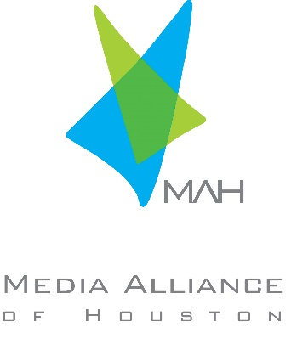
MEDIA ALLIANCE OF HOUSTON SCHOLARSHIP

The Houston Chapter of MAH will award scholarships to College juniors or seniors who have at least one full-time semester left of college. The scholarships will be awarded to students attending a Texas public or private university that offers radio, television, film, public relations, advertising/communications, digital media or broadcasting as the major emphasis of study and/or students from the Greater Houston Area who are studying the aforementioned fields.
Applicants will be considered on the basis of educational and career goals in their major field of study, activities and honors, service to community and references.

ELIGIBILITY REQUIREMENTS
1. Candidate must have completed 75 hours of college course work by December 2022.
2. Candidate may be male or female.
3. Candidate must be currently enrolled as a full-time student (carrying a minimum of 12 hours per semester) with a declared major in radio, television, film, public relations, advertising/communications, digital media or broadcasting.

The Media Alliance of Houston Scholarship Committee will review all applications. This committee will make the final award selection based on the merits of the applicant. The awards will be announced in July 2023.

Application Material Required.

Please type and return the Scholarship Application to the address listed below. Submissions MUST BE postmarked by Friday, May 26th, 2023.

Please submit essay and video with application to: ScholarshipMAH@gmail.com

Entries can also be mailed to:

Disney Advertising
Attn: Sandy Colwell
3310 Bissonnet
Houston, TX 77005
Incomplete or late applications will not be accepted.

Media Alliance of Houston Scholarship Application

I. GENERAL INSTRUCTIONS
1. PLEASE ATTACH AN OFFICIAL SIGNED TRANSCRIPT FOR ALL COLLEGE WORK ATTEMPTED.
2. INCLUDE TWO LETTERS OF REFERENCE FROM A FACULTY MEMBER

II. PERSONAL INFORMATION
1. PLEASE ATTACH RESUME WITH EDUCATIONAL AND EMPLOYMENT INFORMATION

NAME:

EMAIL ADDRESS:

CURRENT MAILING ADDRESS:

CURRENT PHONE:

PERMANENT MAILING ADDRESS:

PERMANENT PHONE:

AGE:

HOW DID YOU LEARN ABOUT THIS SCHOLARSHIP?

V. PERSONAL STATEMENT

1. 250 WORD ESSAY EXPLAINING “WHAT DO YOU THINK THE MEDIA INDUSTRY WILL LOOK LIKE IN 10 YEARS.”

2. A 30-SECOND HOME VIDEO APPLICATION EXPLAINING “WHY DID YOU CHOOSE MEDIA OR RELATED FIELD AS YOUR MAJOR?” (Home video may be shot from phone and emailed or mailed on USB drive).

STUDENT SIGNATURE____________________________________DATE_____________________

Submissions for the 2023 Media Alliance of Houston Scholarship are currently underway. This year both private and public colleges and universities specifically in Texas will be invited to submit candidates. Students who are from the Greater Houston Area studying out of state are also encouraged to apply.

1) Completed 75 hours of college course work by December 2022.
2) Overall GPA of 3.25 or a 3.0 in declared major courses on a 4.0 scale.
3) Must be currently enrolled as a full-time student – carrying a minimum of 12 hours per semester- with a declared major in radio, television, film, public relations, advertising/communications or broadcasting.

The scholarships are to be used for either undergraduate or graduate tuition and will be administered by the respective Financial Aid Office of the recipient. Media Alliance of Houston can only send checks directly to universities, and we cannot cut checks directly to individuals.

For more information contact Sandy Colwell at scholarshipMAH@gmail.com

BrivicMedia Scholarship and Internship Option

In addition to the above scholarship opportunities, the Houston Media Alliance will also be awarding the BrivicMedia Scholarship of $2,500.

BrivicMedia is a full-service media agency providing planning, buying and promotional services for both traditional and digital media. In addition to servicing advertisers directly, BrivicMedia also provides media services for creative agencies, marketing consultants and public relations firms.

Requirements:
- Meet all eligibility requirements stated above for the Houston Media Alliance scholarship.
- Interested in the field of media planning/buying.

To apply for the BrivicMedia Scholarship, please fill out the Houston Media Alliance application and check the box below. Your application will be considered for both scholarship opportunities and you will have the chance to be awarded one.

By checking this box, I would like to be considered for the BrivicMedia, Inc. Scholarship and Internship.

